From John Belton’s *American Cinema/American Culture*, 33-35

MODERNIST NARRATION: *CITIZEN KANE*

#### Unresolved Questions

Modernist works tend to reject the illusionistic transparency of classical realist texts and to bring to the foreground the process of the text’s construction, laying bare its parts, or to expose the process by which its meaning is constructed, or both. Modernist texts convey the spirit of crisis that characterizes the modern (post–Industrial Revolution, twentieth-century) age. They do this, in part, by rejecting the principles of order, regularity, and invisibility that dominate representation in its classical, romantic, and realist forms. The particular form that modernism takes depends on the particular tradition that it rebels against; in American narrative filmmaking, modernism is best exemplified by *Citizen Kane* (1941), a fi lm that breaks the rules of classical narration in several ways.

*Kane* belongs to several fi lm genres. On one level, it is a newspaper fi lm; on another, a mystery; on yet another, it is a fictional biography (or biopic). If it is difficult to classify *Kane* in terms of its exact narrative type, it is also hard to identify its central character. Is it Charles Foster Kane, who dies in its opening minutes? Or is it Thompson, the investigative reporter who is assigned to solve the mystery of Kane’s last word—“rosebud”?

What are the goals of these characters? If what both Kane and Thompson want is “rosebud,” then neither succeeds in getting it. “Rosebud” remains, as far as Kane is concerned, a lost object that he both possesses and can never fi nd; it lies concealed in the vast storehouse of Kane’s possessions. For Thompson, “rosebud” remains a mystery that he never solves. In other words, the goal that structures the narrative is never reached by its central characters (though the audience does penetrate at least one layer of the mystery of “rosebud” in discovering the object to which the word refers).

SEGMENTATION OF CITIZEN KANE

1. The death of Kane
   1. Kane’s death (“No Trespassing”/private; unmediated access to Kane)
   2. “News on the March” obituary (public image of Kane)
2. The search for the meaning of “rosebud” (first-person portraits of Kane)
   1. Unsuccessful interview with Susan
   2. Thatcher’s memoirs/flashback
      1. Kane’s professional success (as yellow journalist)
      2. Kane’s professional failure (forced to relinquish control of newspapers)
   3. Bernstein’s flashback
      1. Kane’s professional success
         1. The rise of the *Inquirer* ii. Celebrating the *Inquirer’* s success
      2. Kane’s personal success
         1. Collecting in Europe ii. Marriage to Emily
   4. Leland’s flashback
      1. Kane’s personal failure (marriage with Emily deteriorates)
      2. Kane’s professional failure (Kane loses the election)
      3. Kane’s personal/professional failure (attempts to make Susan opera star fail)
   5. Susan’s flashback
      1. Kane’s personal/professional failure (attempts to make Susan opera star fail)
      2. Kane’s personal failure (marriage with Susan deteriorates) F. Raymond’s flashback
3. Rosebud (objects tell the story)

#### Artifice Exposed

Though the narration of *Citizen Kane* is extremely fragmented and complex, it can be broken down into three segments. The first segment consists of Kane’s death at Xanadu and public reactions to it, seen in the *News on the March* newsreel. It concludes with the reporter Thompson’s assignment to discover the meaning of Kane’s last word, “rosebud.” The second segment documents

*Citizen Kane* paints a modernist portrait of its central character, played by Orson Welles, as the sum total of various reflections.

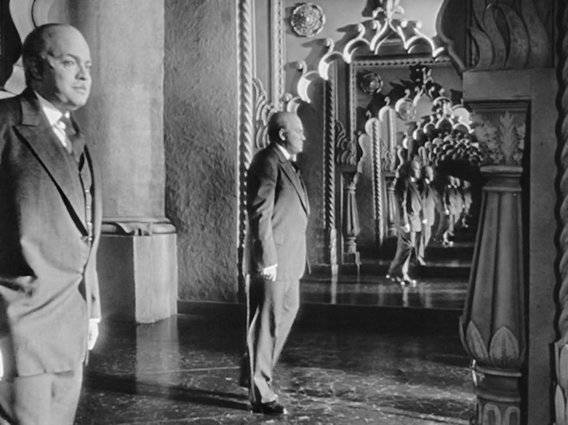

Courtesy of RKO

Thompson’s search. It is structured around a series of five flashbacks presented through Thatcher’s papers and interviews with Mr. Bernstein, Jed Leland, Susan Alexander Kane, and the butler, Raymond. It concludes with Thompson’s admission of failure in finding out what “rosebud” meant. The final segment is extremely brief—only five or six shots. It surveys Kane’s possessions, reveals the identity of “rosebud,” and returns us to the images of Xanadu and the “No Trespassing” sign that began the fi lm.

The first act presents private and public portraits of Kane. The second consists of first-person portraits of Kane that explore his various successes and failures. In the final act, Kane’s possessions stand as yet another way of viewing his life. He *is* the sum total of all of these objects, and it is here that the mystery of “rosebud” is finally solved.

The narrative structure of *Kane* also plays havoc with the norm; it is built around a complex series of overlapping flashbacks in which five different characters present their perceptions of Kane. Though Thompson serves as the audience’s guide through the maze of information presented about Kane, he never processes that information for us. In fact, he refuses, declaring that he “doesn’t think any word [could] explain a man’s life” and that “rosebud” is “just a piece in a jigsaw puzzle—a missing piece.”

Thus, the audience is left with the difficult task of assembling these separate portraits of Kane into a coherent figure. The persistent refusal of the fi lm to give the audience access to its central character serves as the chief mark of its modernism. A “No Trespassing” sign greets us at the beginning of the fi lm; doors are repeatedly closed in our faces; and, once we finally get to see “rosebud” at the end, it goes up in smoke just as we begin to grasp its possible meanings.

*Kane* stands at the very fringe of classical Hollywood cinema and draws much of its power from its violation of the codes and conventions that audiences take for granted when they go to the movies. *Kane* makes visible much of that which the machinery of Hollywood cinema seeks to keep invisible. But even this visibility provides pleasure for audiences, engaging them on a heightened level of narrative awareness that plays a crucial role in their understanding of the narrative.